What are the Practical Application of calculus in real-life situations?

by student’s Name

Course Name
Professor’s Name
Class
Date

What are Practical Applications of Calculus in Real Life Situations?
Introduction
Mathematical literacy plays a significant role in people’s daily lives across the globe. People utilize mathematical concepts such as calculus to improve their wellbeing in society. Sir Isaac Newton invented the calculus concept, a British Scientist, to assist in counting an infinitely smaller number. Consequently, the stage for mathematicians to apply calculus in real life was set out. Calculus is used in sectors such as Engineering, economics, biology, astronomy, among other areas in real-life situations. This paper examines how the concept of calculus affects modern real-life experiences in different fields.
Methodology
This research paper relied on secondary information in peer-reviewed journals. The data analyzed collected covered the last five years from 2014. It includes the specific applications of calculus in the modern world.
The study applied exploratory research design to collect background information regarding applications of Calculus in real-life situations.
Results and Discussion
- Calculus Application in Engineering
The concepts of Calculus and Engineering are inseparable. In almost all aspects of the engineering field, calculus is applied. Calculus is employed in the determination of distances with a high degree of precision. For instance, finding the length of a cable-supported by two poles. The exponential function, which is a subtopic in calculus, is employed in the first-order circuit while the second-order uses the damped sinusoids. An electrical engineer must possess a strong background in calculus to enable him to deal with such issues. Sir Isaac Newton invented calculus to tackles issues to pertaining motion and parameters that bring change with time. The dumped down DC, and simple sinusoidal AC cases usually change with time. Also, the response to those changing signals entails some level of complications in function over a given time. Engineers are required to analyze the second-order circuits until they become second nature to evaluators. After that, they begin tacking step function, impulse functions as well as other tools required to analyze the response of complicated signals in complicated circuits. Therefore, they would need calculus knowledge to deal with Fourier analysis.
- Calculus Application in Economics
The economics utilize the calculus concepts in purchase decisions. Economists are keen on numbers and want to perform their tasks with a perfectionist. Also, they want to prevent instances of purchasing less or more commodities. Knowledge in calculus assists economists examine the exact period they can buy goods as well as sell them. They also determine the number of people purchasing the commodities, the marginal values of any given product. Therefore, calculus plays a crucial role in the determination of the direction that a business would take. It is because some commodities prices are determined by various aspects such as the weather conditions, availability of commodities, and availability of the market. Failure to utilize the calculus concept may result in poor purchasing and selling decisions hence negatively impacting their business.
- Calculus Application in Biology
Calculus is employed in numerous applications and functionalities in biology. Biologists apply calculus concepts in the growth rate of bacteria. Most undergraduate students pursuing biology majors are also advised to take calculus courses. Calculus applications assist the students in designing dynamic modeling as well as statistical modeling. The basic concepts are preferred because the biological students need to fully understand statistics at the level of genuinely thinking about their data critically without necessarily implying the tests without any proper procedures and protocol. The students require some necessary information in calculus rather than complicated calculus. Therefore, calculus application in biology is essential because it assists in tackling issues related to quantitative models. The calculus concept in determining population growth rates.
The calculus derivatives are employed in derivatives for various functions. For instance, it is used to determine the rate of muscle contradiction, frequency of drug dissolution into the bloodstream, as well as the growth of bacteria. Noyes Whitney equation is used to determine the ending of drugs into the blood of human bodies.
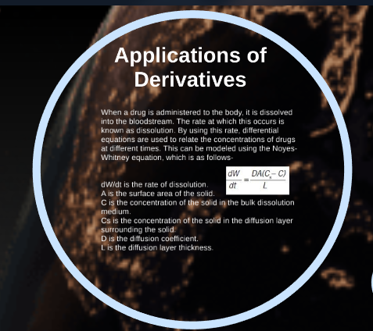
Figure 1

Source: https://prezi.com/t-o0j-bsvilp/uses-of-calculus-in-biology/
- Calculus applications in Astronomy
In the field of Astronomy, calculus plays a significant role in solving the non-discrete calculation and continuous functionality, especially when the functions create their own respective functions. For instance, the force of gravity and distance from earth effects velocity. In this case, calculus is employed to explain the phenomena and solve the regarding the gravitational force. The astronomers also use calculus to determine the specific place to land, particularly on the money concerning rocket trajectory.
Furthermore, the Astronomers carefully use calculus concepts to enable them to calculate the variable speed of any objects in moving in the space that includes comets, celestial bodies, and asteroids.
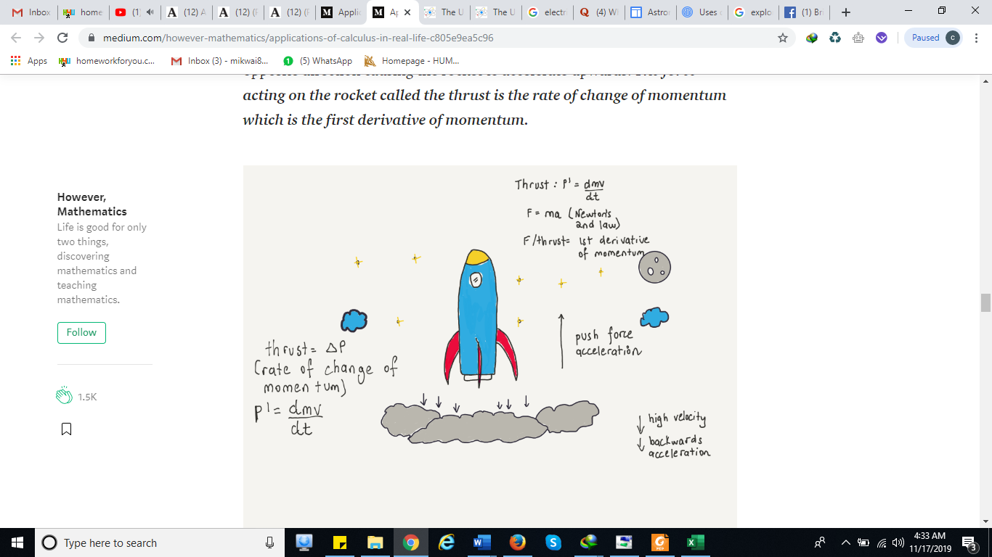
Figure 2

Source: https://medium.com/however-mathematics/applications-of-calculus-in-real-life-c805e9ea5c96
Significance of study, Limitation, and conclusion
This study plays a significant role as it explores the real-life applications of the Calculus in real-life situations. The students can utilize this study to acquire knowledge regarding the implementation of calculus. This would help them understand and develop an interest in learning calculus courses.
There are limited data materials on the topic of study. This created challenges in determining various scholars’ contributions and perspectives on the subject matter. Therefore, there is a need for scholars and researchers to engage in research to examine whether learning calculus affects the learner's career choices in the future.
In conclusion, learners need exposure to real-life situations. They need to interreact with professionals such as engineers, biotechnologists, astronomers, and economists to gather relevant information. Such information would assist them in making informed decisions about why they need to take a calculus course during their studies.

Bibliography
Bressoud, David, Imène Ghedamsi, Victor Martinez-Luaces, and Günter Törner. "Teaching and learning of calculus." In Teaching and Learning of Calculus, pp. 1-37. Springer, Cham, 2016.
Falcionelli, Nicola, Paolo Sernani, Albert Brugués, Dagmawi Neway Mekuria, Davide Calvaresi, Michael Schumacher, Aldo Franco Dragoni, and Stefano Bromuri. "Indexing the event calculus: towards practical human-readable personal health systems." Artificial intelligence in medicine 96 (2019): 154-166.
More, M. "Mathematics and engineering in real life through mathematical competitions." International Journal of Mathematical Education in Science and Technology 49, no. 2 (2018): 305-321.
Smith, Cathy, and Candia Morgan. "Curricular orientations to real-world contexts in mathematics." The Curriculum Journal 27, no. 1 (2016): 24-45.

Falcionelli, et al., "Indexing the event calculus,”154-166.
More, "Mathematics and engineering in real life through mathematical,” 305-321.
Smith, et al.,"Curricular orientations to real-world contexts in mathematics," 24-45.
Bressoud et al., "Teaching and learning of calculus, 1-37.
Bressoud et al., "Teaching and learning of calculus, 1-37.

